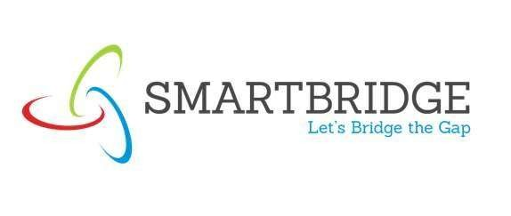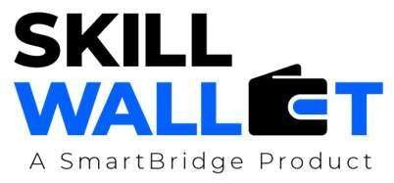
Initial Project Planning Template
 |  | Date |  |  | 30 SEPT 2026
 |  | Team ID |  |  | SWTID-2026-9948
 |  | Project Name |  |  | EduGenie – AI Learning Assistant
 |  | Maximum Marks |  |  | 5 Marks
Sprint | Functional  Requirement (Epic) |  | User Story  Number | User Story / Task |  | Story Points | Priority | Sprint Start  Date |  | Sprint End Date  (Planned)
Sprint-1 | User  Authentication |  | USN-1 | Users can register and login securely using JWT authentication. |  | 3 | High | 27-06-2026 |  | 29-06-2026
Sprint-1 | User Dashboard |  | USN-2 | Users can access an interactive dashboard after login |  | 52 | High | 27-06-2026 |  | 02-07-2026
Sprint-2 | Q&A Assistant |  | USN-3 | Students can ask educational questions using Gemini AI. |  | 5 | High | 03-07-2026 |  | 06-07-2026

Product Backlog, Sprint Schedule, and Estimation (4 Marks)
This project plan outlines the user stories, sprint schedule, priorities, and estimated effort required to develop the Emotion Detection & Learning Support Engine. It organizes the development process into manageable sprints, ensuring that core features are implemented systematically, tested, and delivered within the planned timeline.

Sprint-2 | Concept  Explainer | USN-4 | Explain concepts in simple language using LaMini-Flan-T5. | 2 | Medium | 03-07-2026 | 06-07-2026
Sprint-3 | Quiz Generator | USN-5 | Generate MCQs dynamically using Gemini API. | 2 | Medium | 07-07-2026 | 09-07-2026
Sprint-3 | Content  Summarizer | USN-6 | Summarize educational content and notes. | 3 | High | 07-07-2026 | 10-07-2026

